Supplementary material
Julieta Solórzano Salas et al., 2024

Results obtained with the Bayesian analysis in the special teachers group
blavaan (0.3-15) results of 5000 samples after 5000 adapt/burnin iterations
Number of observations 80
Number of missing patterns 1
Statistic MargLogLik PPP
Value -250.598 0.134

Regressions:
Estimate Post.SD pi.lower pi.upper Std.lv Std.all Rhat Prior
CSMF ~
ACTRND 0.183 0.050 0.084 0.282 0.183 0.334 1.000 normal(0,10)
MDFAM -0.098 0.033 -0.164 -0.033 -0.098 -0.198 1.000 normal(0,10)
MDPAR 0.040 0.035 -0.029 0.108 0.040 0.089 1.000 normal(0,10)
MDMC 0.079 0.031 0.018 0.139 0.079 0.178 1.000 normal(0,10)
ASHFI 0.171 0.057 0.06 0.284 0.171 0.271 1.000 normal(0,10)
NCSF ~
ASHFO 0.017 0.073 -0.126 0.16 0.017 0.027 1.000 normal(0,10)
NACTRD -0.208 0.079 -0.365 -0.055 -0.208 -0.292 1.000 normal(0,10)
NSEX 0.215 0.193 -0.167 0.59 0.215 0.095 1.000 normal(0,10)
NAS -0.164 0.100 -0.362 0.031 -0.164 -0.149 1.000 normal(0,10)
NCASI ~
FES 0.065 0.052 -0.037 0.166 0.065 0.131 1.000 normal(0,10)
NCAES -0.113 0.048 -0.207 -0.019 -0.113 -0.245 1.000 normal(0,10)
NASPCDN 0.061 0.036 -0.011 0.132 0.061 0.256 1.000 normal(0,10)
NASPCDP 0.047 0.018 0.012 0.083 0.047 0.339 1.000 normal(0,10)
NAESN -0.090 0.029 -0.147 -0.032 -0.090 -0.401 1.000 normal(0,10)
NAESP 0.014 0.026 -0.037 0.065 0.014 0.063 1.000 normal(0,10)
AEFIC 0.010 0.013 -0.016 0.036 0.010 0.086 1.000 normal(0,10)
CSMF -0.046 0.029 -0.105 0.011 -0.046 -0.206 1.000 normal(0,10)
NCSF -0.030 0.029 -0.087 0.027 -0.030 -0.147 1.000 normal(0,10)
AEFIC ~
CSMF 0.389 0.279 -0.161 0.937 0.389 0.200 1.000 normal(0,10)
NCSF 0.249 0.285 -0.312 0.811 0.249 0.139 1.000 normal(0,10)

Covariances:
Estimate Post.SD pi.lower pi.upper Std.lv Std.all Rhat Prior
.CSMF ~~
.NCSF 0.127 0.030 0.077 0.192 0.127 0.612 1.000 beta(1,1)

Intercepts:
Estimate Post.SD pi.lower pi.upper Std.lv Std.all Rhat Prior
.CSMF -0.602 0.204 -1.008 -0.201 -0.602 -1.154 1.000 normal(0,10)
.NCSF 1.192 0.223 0.765 1.633 1.192 2.104 1.000 normal(0,10)
.NCASI 0.766 0.102 0.562 0.967 0.766 6.531 1.000 normal(0,10)
.AEFIC 3.346 0.184 2.986 3.709 3.346 3.292 1.000 normal(0,10)

Variances:
Estimate Post.SD pi.lower pi.upper Std.lv Std.all Rhat Prior
.CSMF 0.147 0.025 0.106 0.203 0.147 0.539 1.000 gamma(1,.5)[sd]
.NCSF 0.292 0.050 0.211 0.408 0.292 0.908 1.000 gamma(1,.5)[sd]
.NCASI 0.010 0.002 0.007 0.013 0.010 0.697 1.000 gamma(1,.5)[sd]
.AEFIC 0.940 0.156 0.68 1.284 0.940 0.910 1.000 gamma(1,.5)[sd]

Diagnóstico del modelo EE

índices de ajuste
npar logl ppp bic dic p_dic waic p_waic se_waic
29.000 -102.262 0.134 331.239 261.073 28.274 265.718 29.310 28.059
looic p_loo se_loo margloglik
267.673 30.287 28.557 -250.598

Lagunas trazas

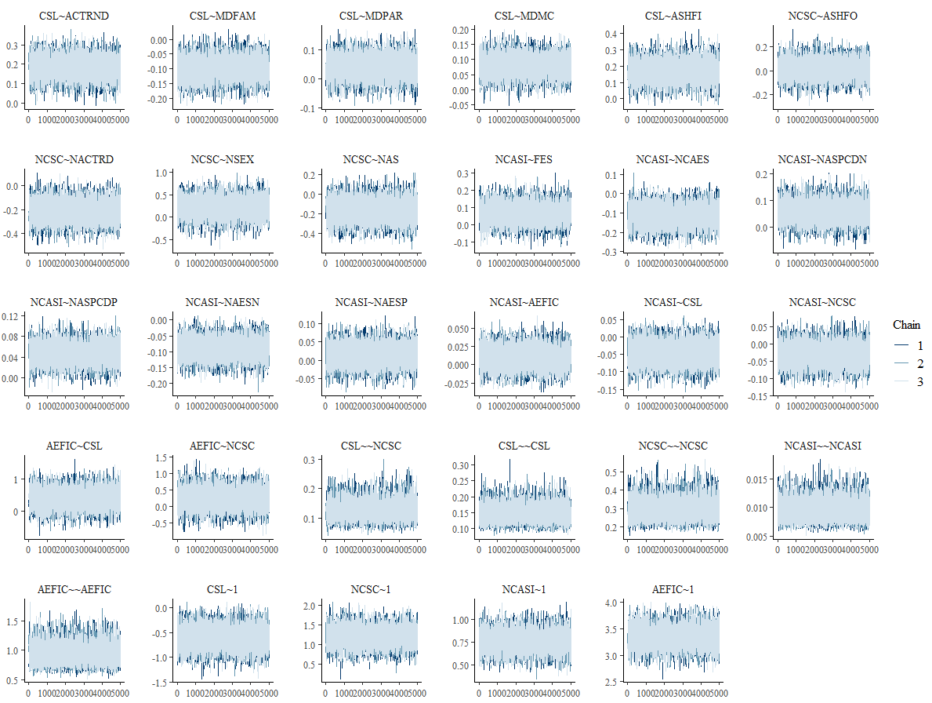
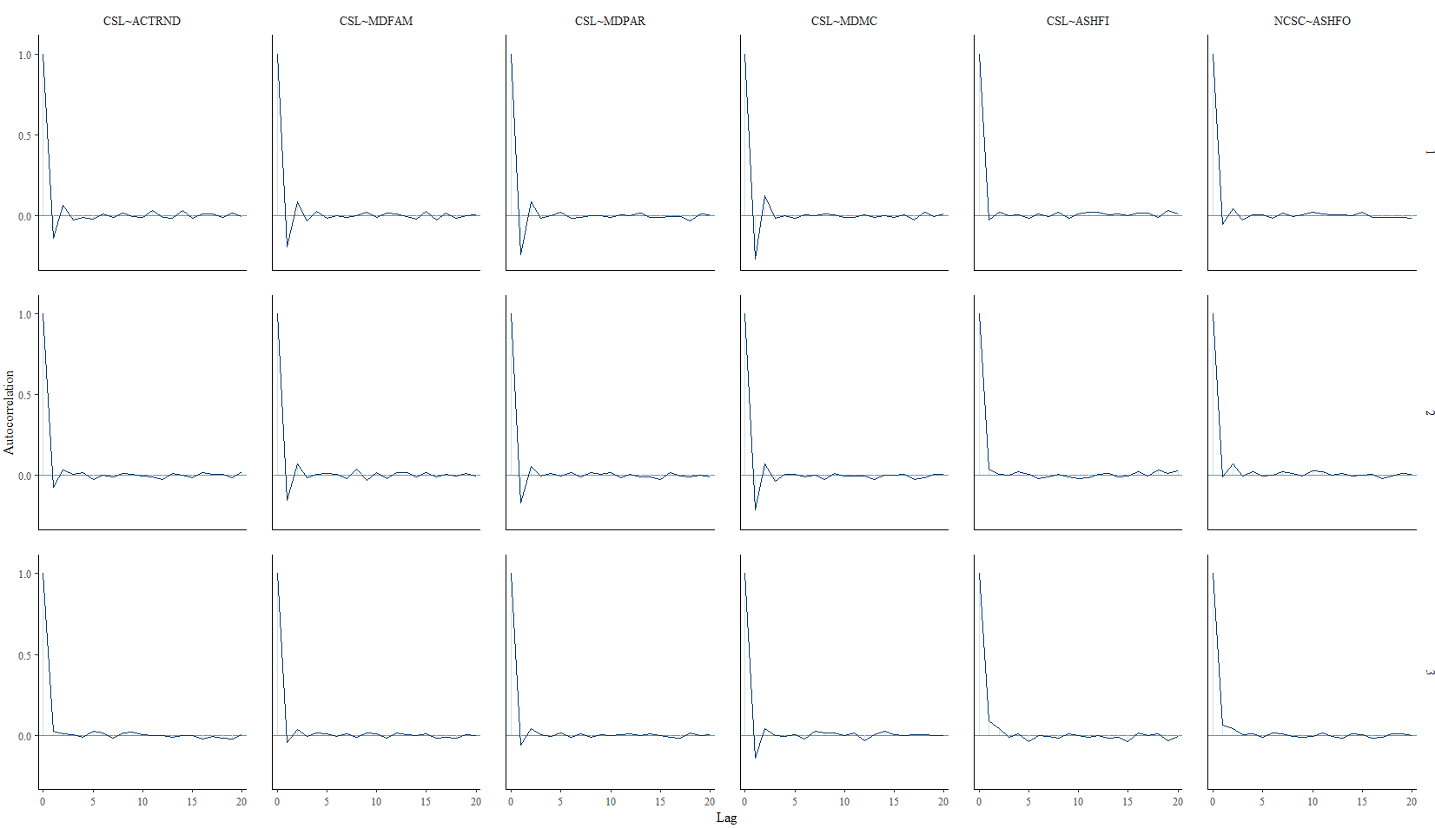

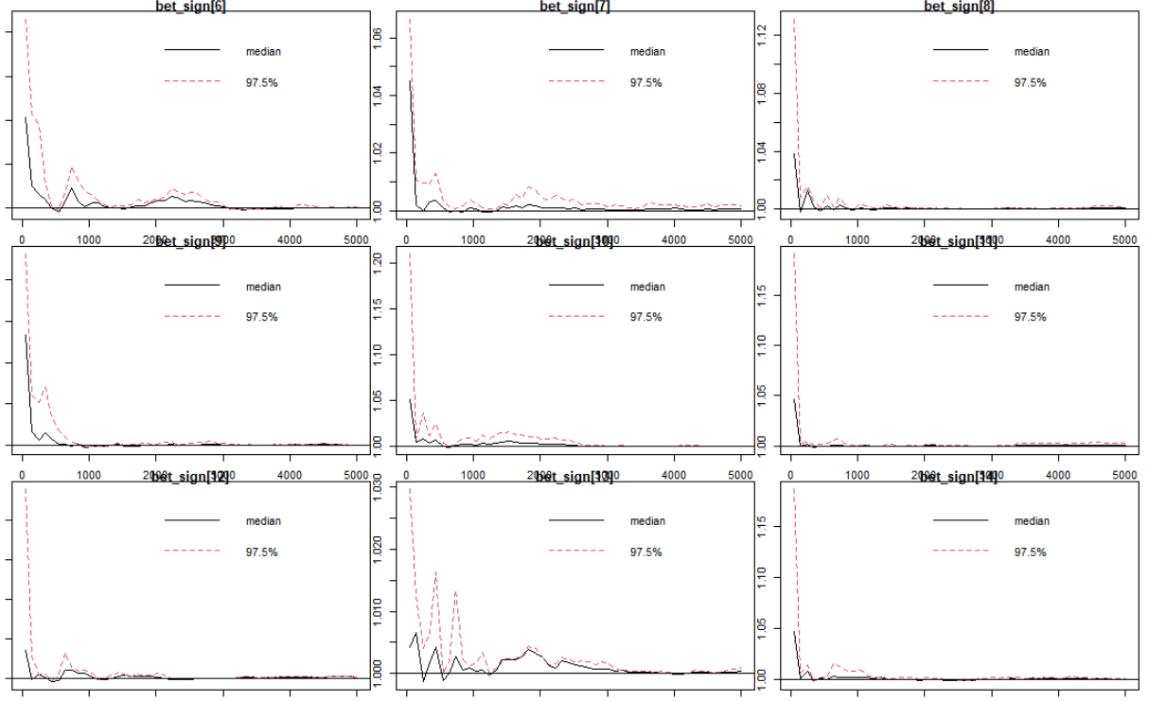

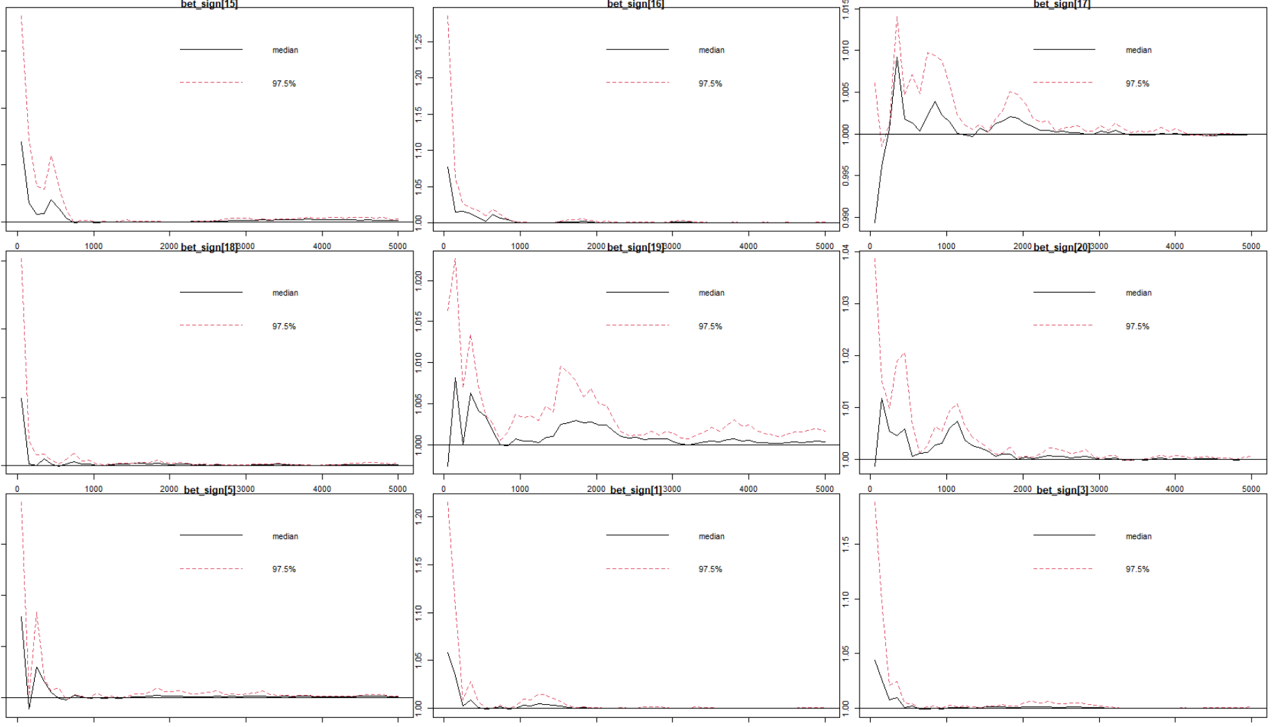

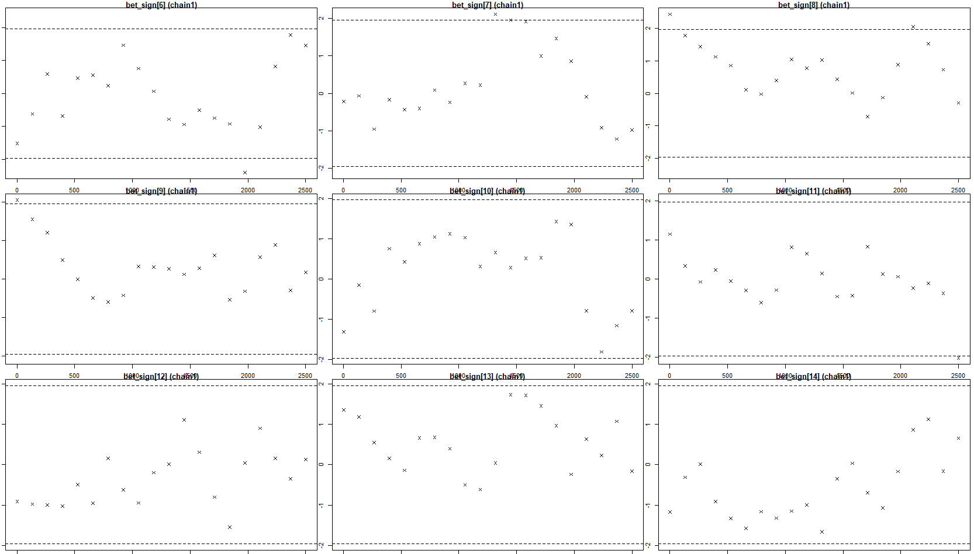

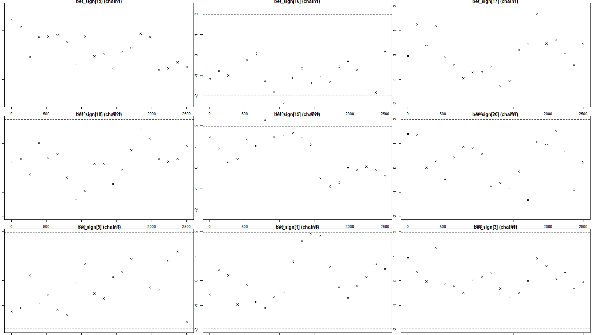

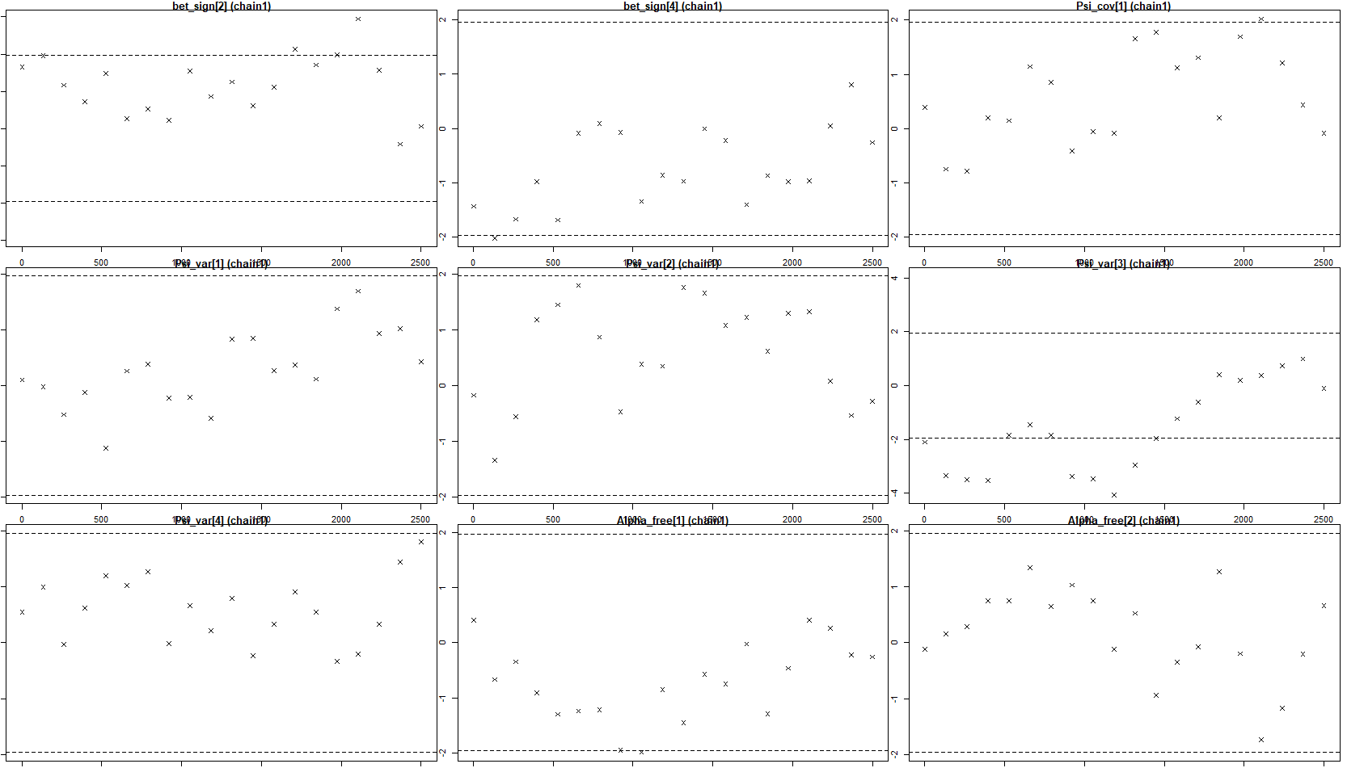

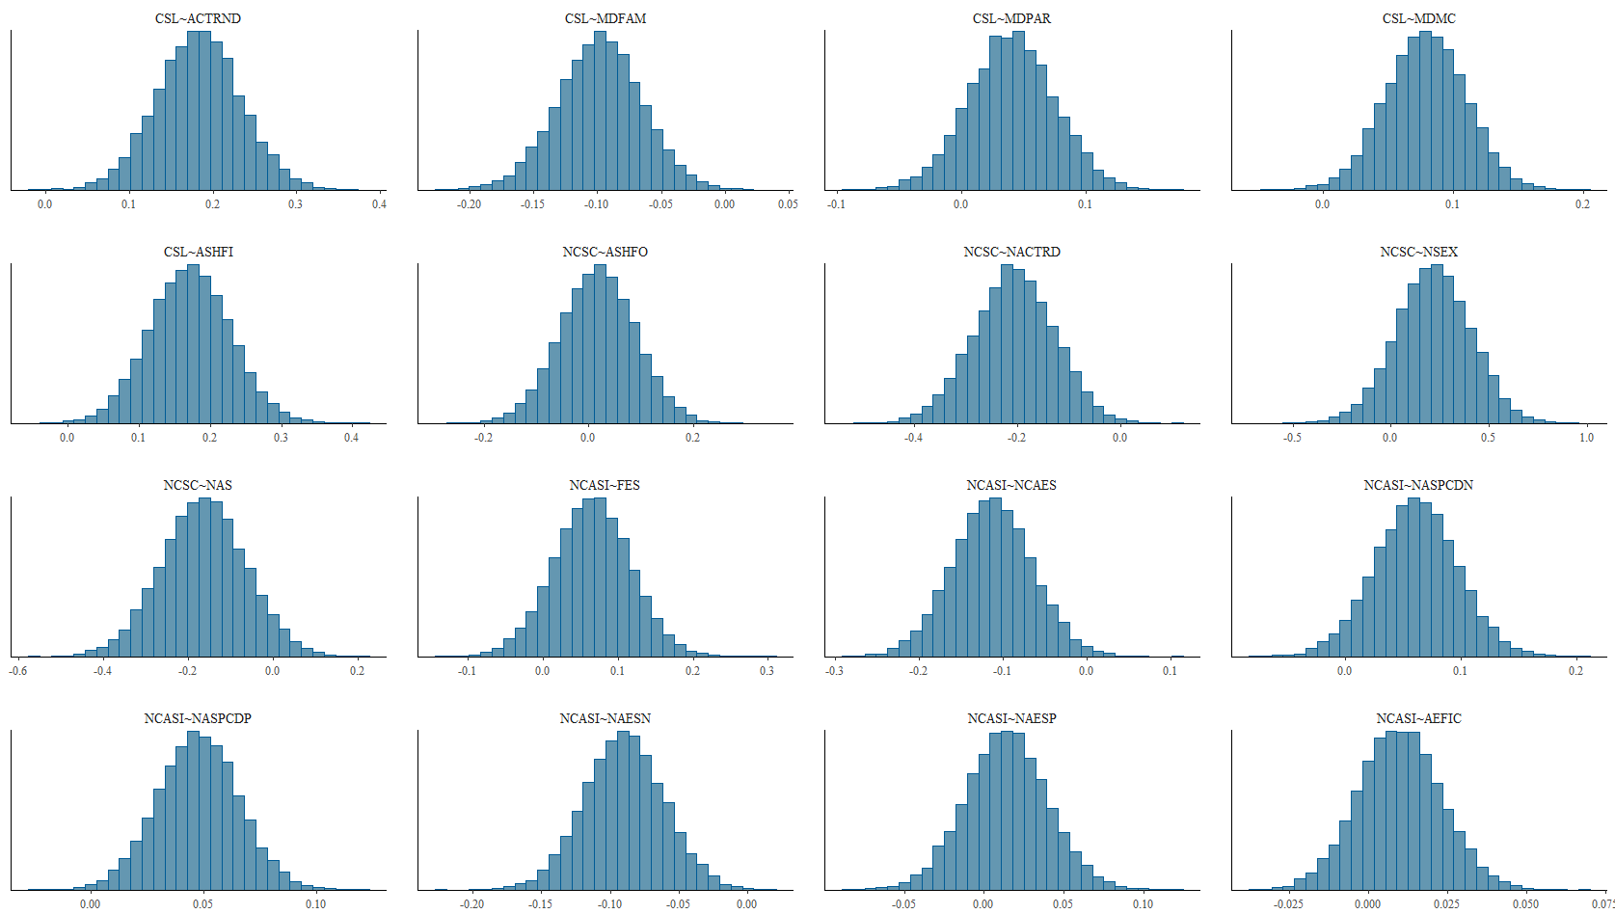

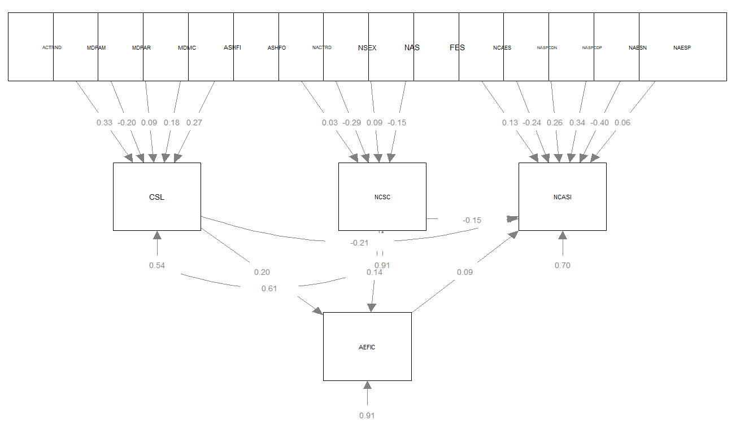

Results obtained with the Bayesian analysis in the comparative group

blavaan (0.3-15) results of 5000 samples after 5000 adapt/burnin iterations
Number of observations 52
Number of missing patterns 1
Statistic MargLogLik PPP
Value -235.764 0.007

Regressions:
Estimate Post.SD pi.lower pi.upper Std.lv Std.all Rhat Prior
NCSMF ~
ACTRND 0.181 0.083 0.019 0.342 0.181 0.249 1.000 normal(0,10)
NMDFAM -0.166 0.049 -0.26 -0.07 -0.166 -0.319 1.000 normal(0,10)
MDPAR 0.077 0.054 -0.029 0.181 0.077 0.147 1.000 normal(0,10)
MDMC 0.057 0.057 -0.055 0.17 0.057 0.100 1.000 normal(0,10)
NASHFI 0.351 0.103 0.15 0.559 0.351 0.414 1.000 normal(0,10)
NCSF ~
ASHFO -0.209 0.154 -0.507 0.096 -0.209 -0.239 1.000 normal(0,10)
NACTRD -0.260 0.236 -0.721 0.208 -0.260 -0.184 1.000 normal(0,10)
SEXM -0.679 0.415 -1.499 0.139 -0.679 -0.211 1.000 normal(0,10)
AS 0.079 0.126 -0.168 0.328 0.079 0.083 1.000 normal(0,10)
NCASI ~
FES 0.004 0.065 -0.124 0.13 0.004 0.009 1.000 normal(0,10)
NCAES 0.063 0.053 -0.041 0.169 0.063 0.179 1.000 normal(0,10)
ASPCDN 0.047 0.029 -0.008 0.105 0.047 0.293 1.000 normal(0,10)
ASPCDP 0.014 0.035 -0.055 0.084 0.014 0.088 1.000 normal(0,10)
NAESN -0.080 0.046 -0.171 0.011 -0.080 -0.297 1.000 normal(0,10)
NAESP 0.004 0.043 -0.08 0.089 0.004 0.014 1.000 normal(0,10)
NAEFIC -0.006 0.016 -0.037 0.025 -0.006 -0.057 1.000 normal(0,10)
NCSMF 0.007 0.028 -0.048 0.062 0.007 0.046 1.000 normal(0,10)
NCSF -0.001 0.018 -0.036 0.033 -0.001 -0.012 1.000 normal(0,10)
NAEFIC ~
NCSMF -0.057 0.253 -0.553 0.441 -0.057 -0.037 1.000 normal(0,10)
NCSF 0.117 0.168 -0.215 0.447 0.117 0.115 1.000 normal(0,10)

Covariances:
Estimate Post.SD pi.lower pi.upper Std.lv Std.all Rhat Prior
.NCSMF ~~
.NCSF -0.017 0.060 -0.139 0.099 -0.017 -0.049 1.000 beta(1,1)

Intercepts:
Estimate Post.SD pi.lower pi.upper Std.lv Std.all Rhat Prior
.NCSMF -1.093 0.362 -1.812 -0.379 -1.093 -1.723 1.000 normal(0,10)
.NCSF 3.927 0.479 2.989 4.862 3.927 4.071 1.000 normal(0,10)
.NCASI 0.879 0.274 0.334 1.409 0.879 8.514 1.000 normal(0,10)
.NAEFIC 3.672 0.458 2.776 4.567 3.672 3.750 1.000 normal(0,10)

Variances:
Estimate Post.SD pi.lower pi.upper Std.lv Std.all Rhat Prior
.NCSMF 0.167 0.037 0.109 0.253 0.167 0.414 1.000 gamma(1,.5)[sd]
.NCSF 0.757 0.166 0.501 1.139 0.757 0.814 1.000 gamma(1,.5)[sd]
.NCASI 0.009 0.002 0.006 0.014 0.009 0.837 1.000 gamma(1,.5)[sd]
.NAEFIC 0.946 0.200 0.632 1.406 0.946 0.987 1.000 gamma(1,.5)[sd]

Diagnóstico del modelo EE

índices de ajuste
npar logl ppp bic dic p_dic waic p_waic se_waic
29.000 -98.659 0.007 311.341 252.972 27.827 256.804 27.488 25.049
looic p_loo se_loo margloglik
259.386 28.779 25.589 -235.764

Lagunas trazas

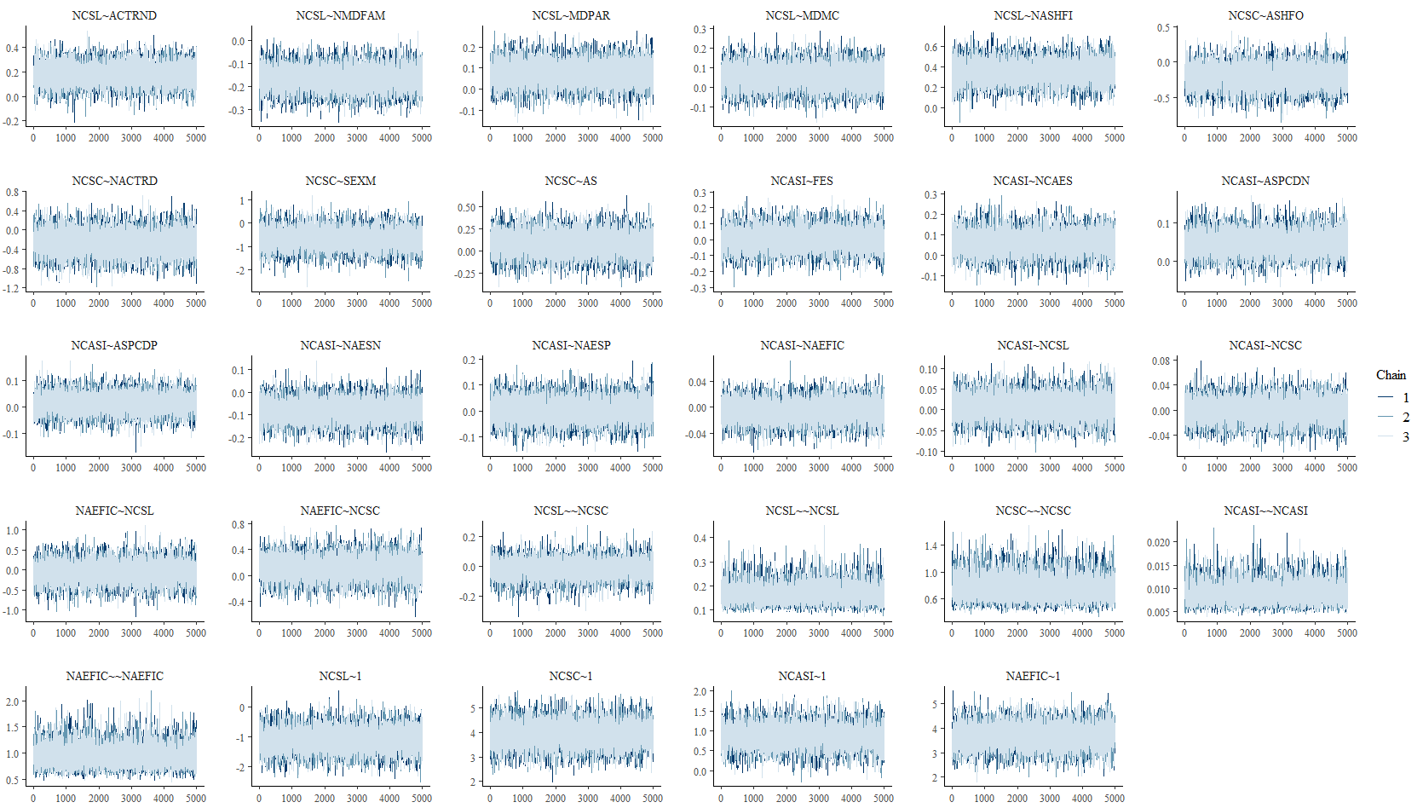
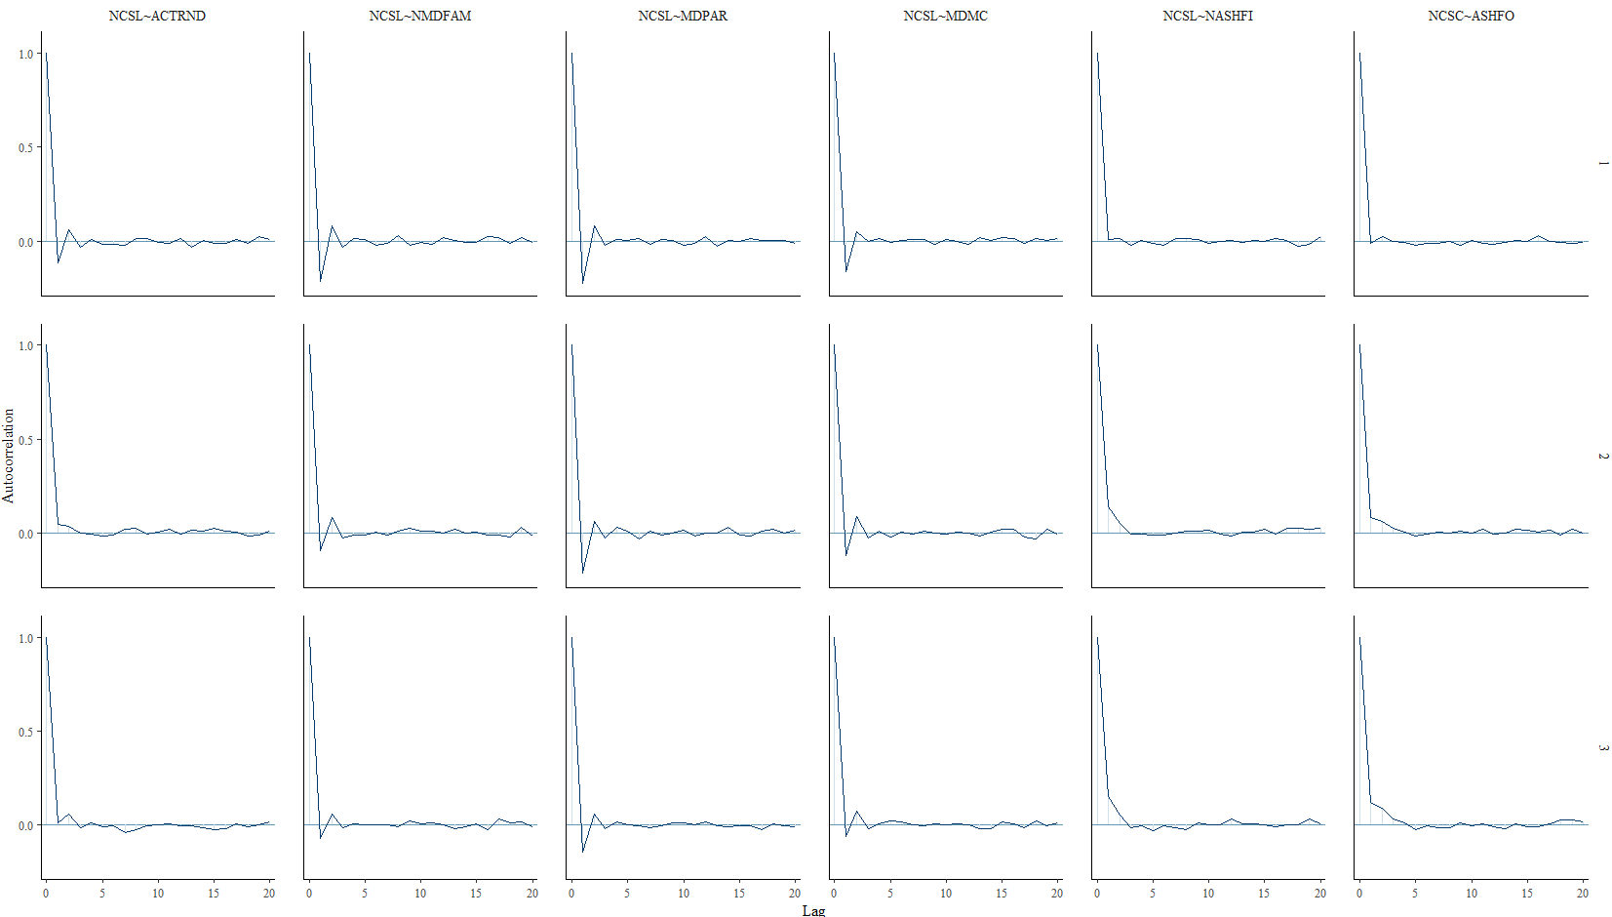

Diagnóstico de Gelman y Rubin

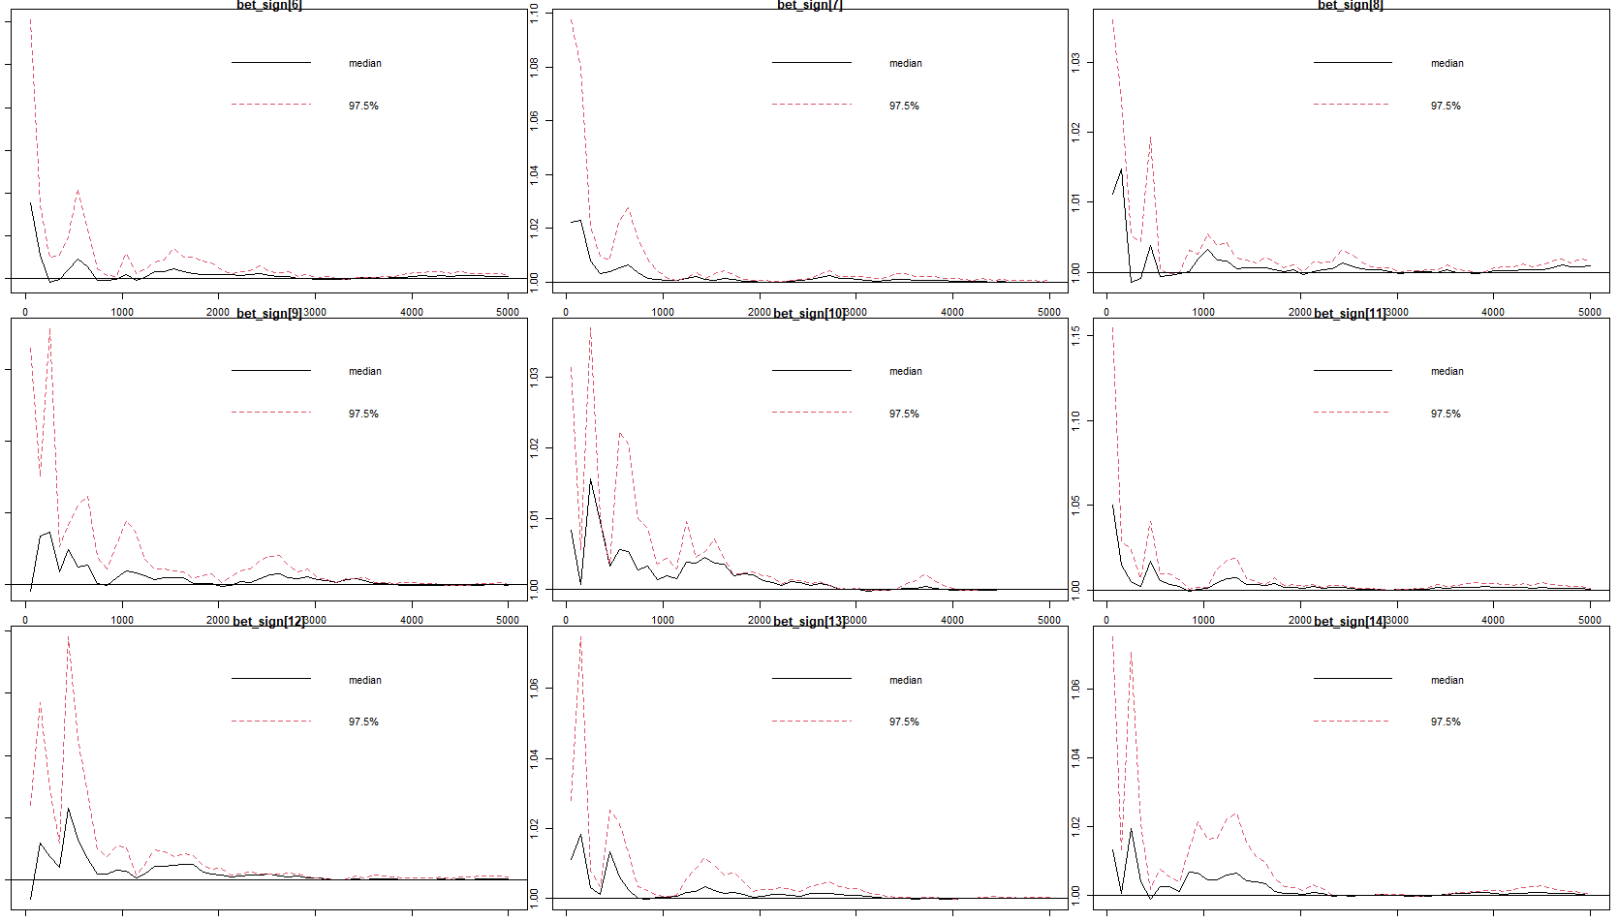

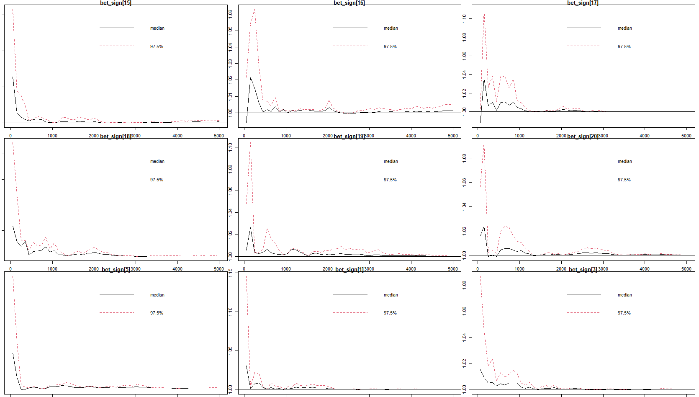

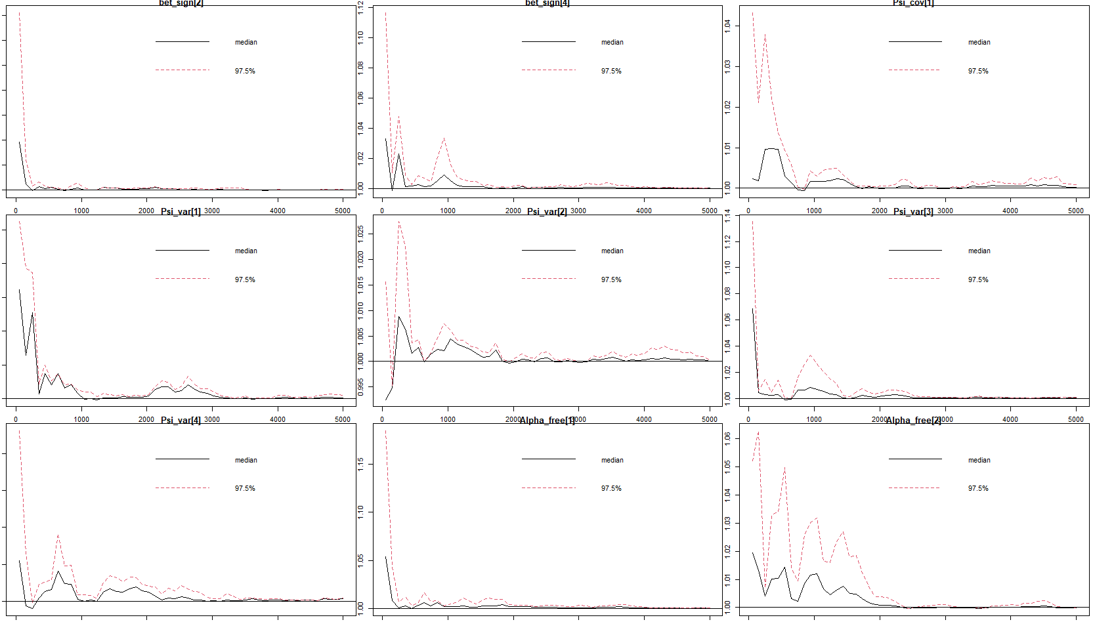

Diagnóstico de Geweke
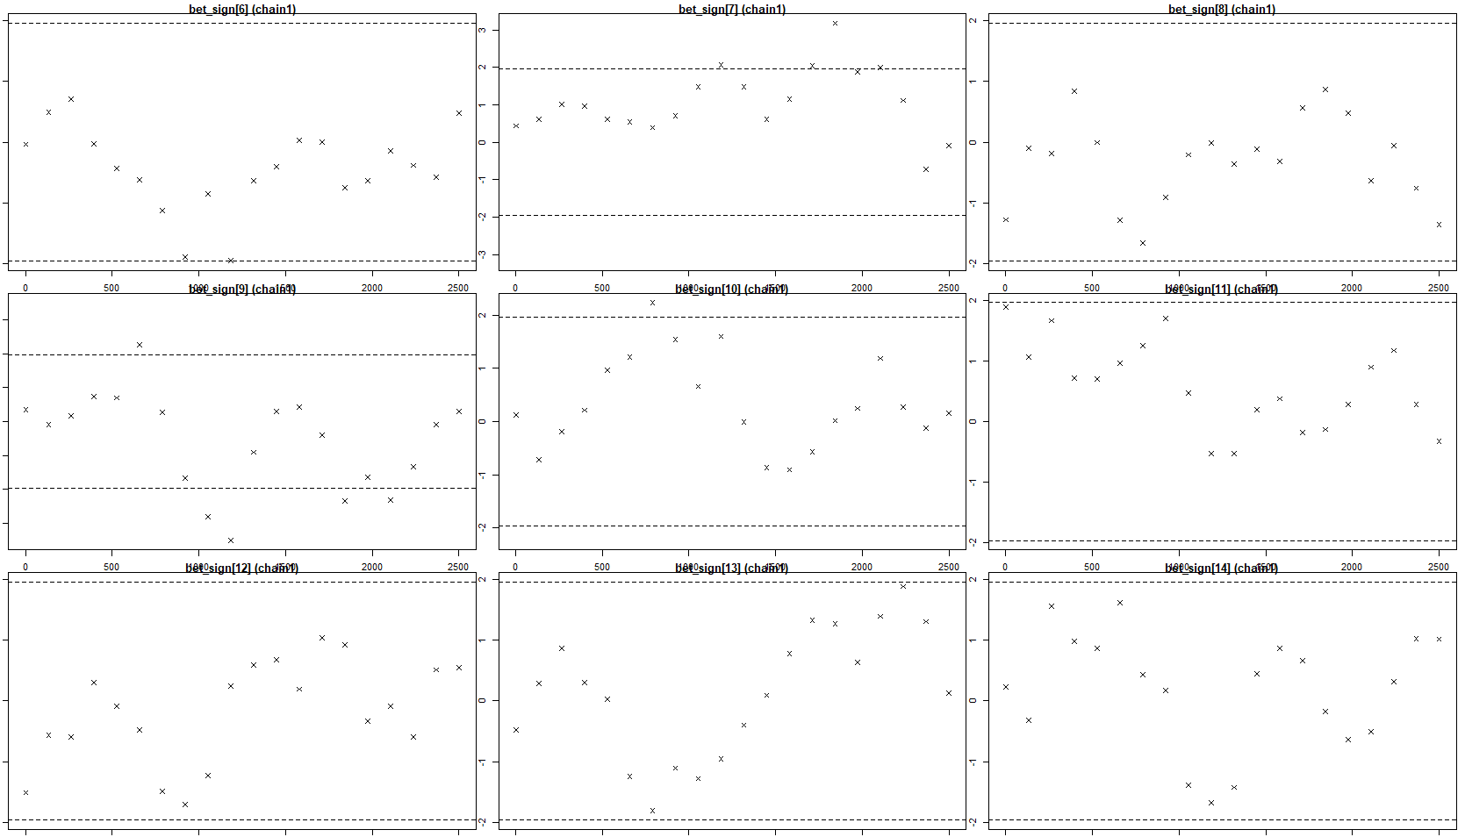

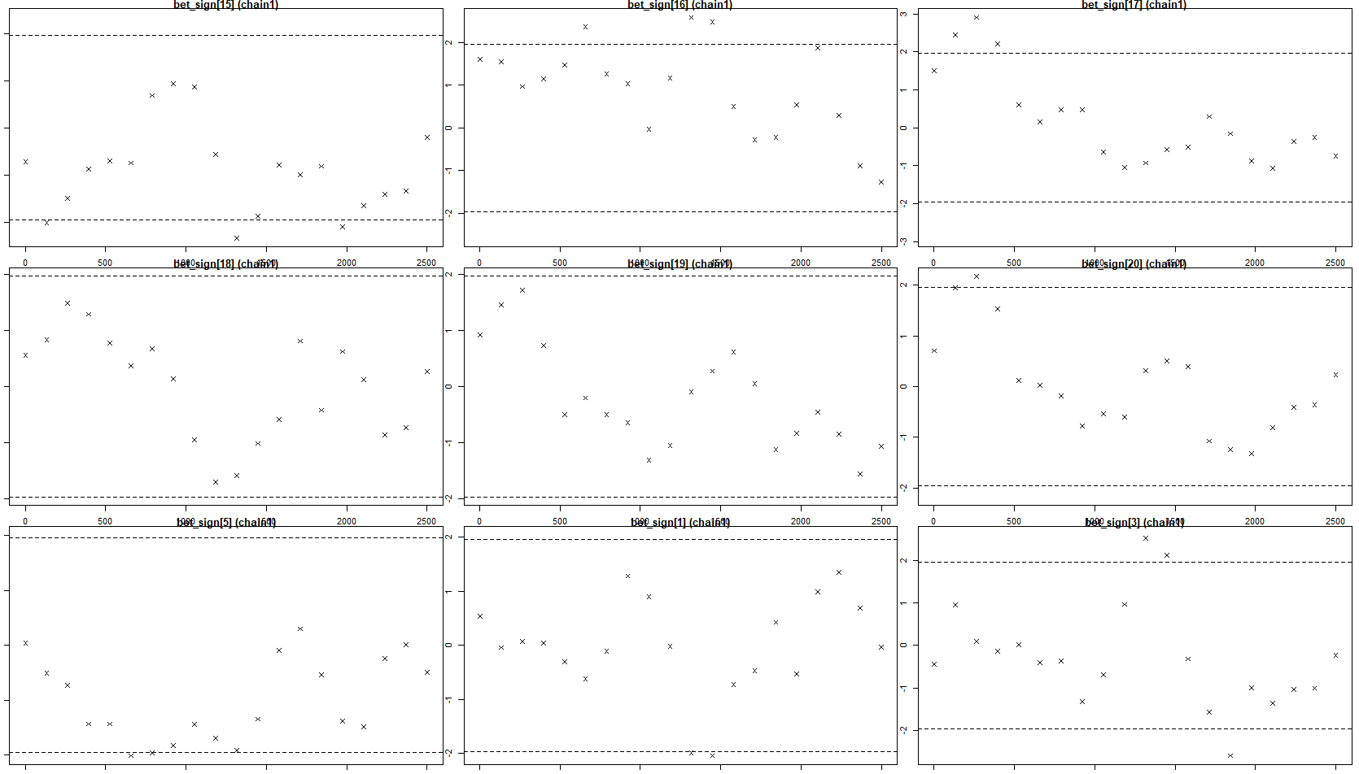

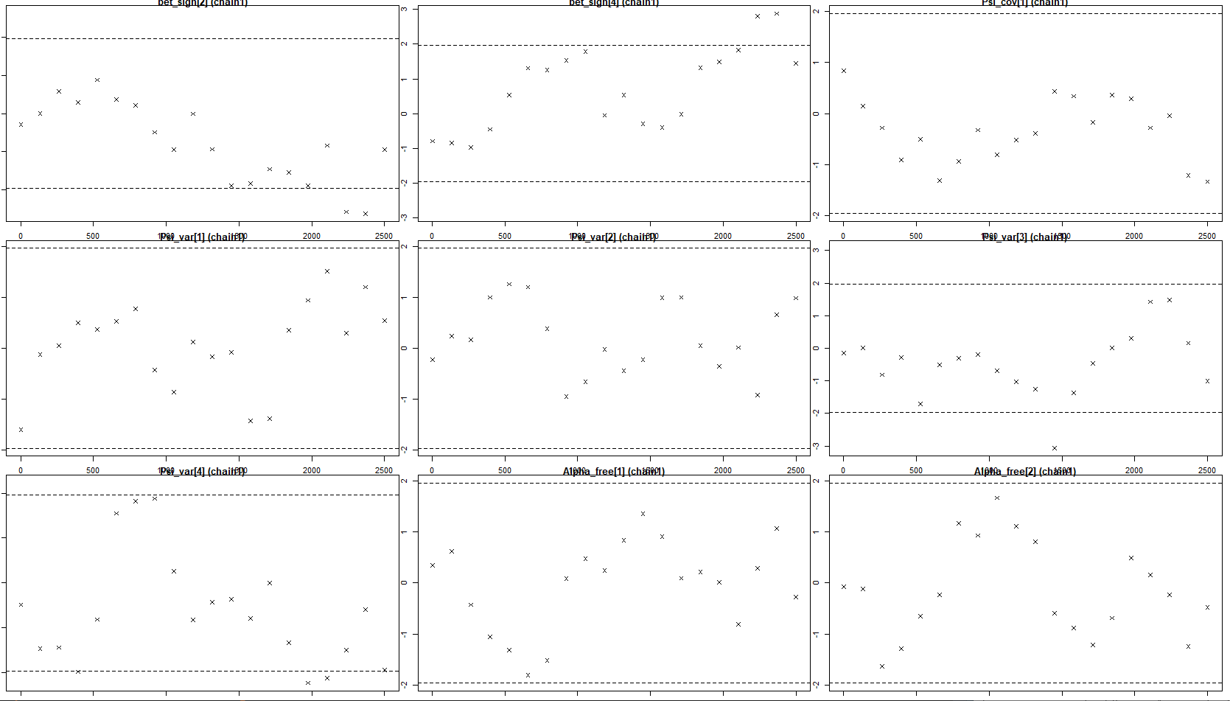

Ahora vemos que el diagnóstico de Gelman y Rubin (PRSF) está cerca de 1 para todos los
parámetros y el diagnóstico de Geweke no es >1.96.

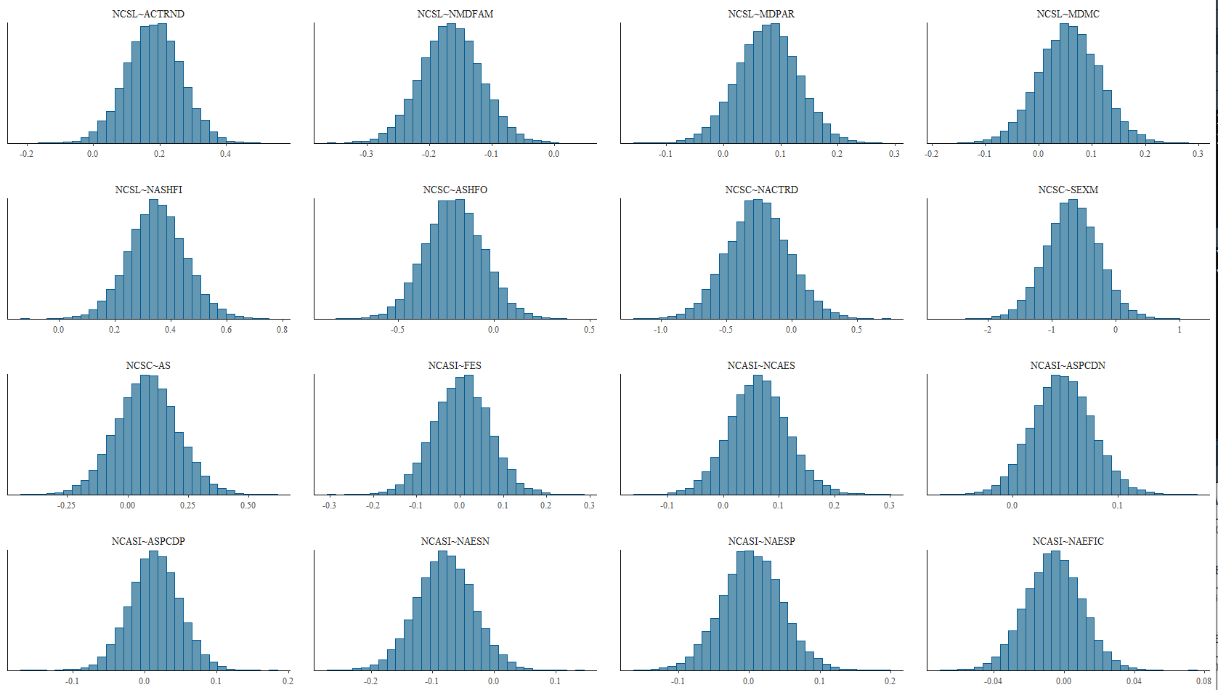

CÓDIGO EN R

library(blavaan)
library(haven)
library(semPlot)
#library(rjags)
library(psych) #to get some extended summary statistics
library(tidyverse) # needed for data manipulation and plotting
library(bayesplot)
library(coda)

# Eliminar todo de la memoria
rm(list=ls())

# Cargar los datos
EEMOD <- read_sav("EEMOD.sav")
GCMOD <- read_sav("GCMOD.sav")

# ----------------------------
# Definición del modelo modEE
# ----------------------------

modEE <- '
# Regresiones

CSMF ~ ACTRND + MDFAM + MDPAR + MDMC + ASHFI
NCSF ~ ASHFO + NACTRD + NSEX + NAS
NCASI ~ FES + NCAES + NASPCDN + NASPCDP + NAESN + NAESP

NCASI ~ AEFIC + CSMF + NCSF
AEFIC ~ CSMF + NCSF

# Correlaciones
CSMF ~~ NCSF
'
# ------------------------
# Setup para el modelo
# ------------------------

# Ejecutiar la estimación con 3 cadenas, cada una de 5000 de quemado y 5000 de muestra.
bfit <- bsem(modEE, data=EEMOD, target = "stan",n.chains = 3, burnin = 5000,
sample = 5000, mcmcfile = TRUE)

# Solución completamente estandarizada
summary(bfit,standardized=T)

# Otra forma de ver las estimaciones
#parameterestimates(bfit, ci = F, standardized = T)

# ------------------------
# Diagnósticos del modelo
# ------------------------

# Indices de Ajuste
fitmeasures(bfit)

# Trazas de las cadenas
plot(bfit)

# Autocorrelaciones
plot(bfit, pars = 1:6, plot.type = "acf")

# Diagnóstico de Gelman y Rubin
mcmc.list <- blavInspect(bfit, what = "mcmc")
gelman.diag(mcmc.list)

par(mar=c(1,1,1,1))
gelman.plot(mcmc.list)

# Diagnóstico de Geweke
geweke.plot(mcmc.list)

# Comentario:
# Ahora vemos que el diagnóstico de Gelman y Rubin (PRSF) está cerca de 1 para todos los
# parámetros y el diagnóstico de Geweke no es >1.96.

# Densidades posteriori
par(mfrow=c(1,1))
MCMCbinded <- as.matrix(mcmc.list)
plot(density(MCMCbinded[,1]) , main = "bet_sign[6]")

# Densidades a posteriori
par(mfrow=c(2,2))
plot(bfit , pars = 1:4, plot.type = "hist")

# ------------------------
# Diagrama de Senderos
# ------------------------

semPaths(bfit, intercept = FALSE, whatLabel = "std",
residuals = TRUE, exoCov = FALSE,layout="tree2", style="lisrel",sizeMan = 10,rotation = 1,
edge.label.cex = 1.5,nCharNodes=0,
nCharEdges=1,curveAdjacent = TRUE)
title("EEMOD", line = 3)

# ---------------------------------------------------------------------------#

# ----------------------------
# Definición del modelo modEE
# ----------------------------

modGC <- '
# Regresiones
NCSMF ~ ACTRND +NMDFAM+ MDPAR+ MDMC+ NASHFI
NCSF ~ ASHFO +NACTRD +SEXM +AS
NCASI ~ FES+ NCAES+ ASPCDN +ASPCDP +NAESN +NAESP

NCASI ~ NAEFIC+ NCSMF+ NCSF
NAEFIC ~ NCSMF+ NCSF

# Correlaciones
NCSMF ~~ NCSF
'

# ------------------------
# Setup para el modelo
# ------------------------

bfit1 <- bsem(modGC, data=GCMOD, target = "stan",n.chains = 3, burnin = 5000,
sample = 5000, mcmcfile = TRUE)

# Solución completamente estandarizada
summary(bfit1,standardized=T)

# Otra forma de ver las estimaciones
#parameterestimates(bfit1, ci = F, standardized = T)

# ------------------------
# Diagnósticos del modelo
# ------------------------

# Indices de Ajuste
fitmeasures(bfit1)

# Trazas de las cadenas
plot(bfit1)

# Autocorrelaciones
plot(bfit1, pars = 1:6, plot.type = "acf")

# Diagnóstico de Gelman y Rubin
mcmc.list <- blavInspect(bfit1, what = "mcmc")
gelman.diag(mcmc.list)

par(mar=c(1,1,1,1))
gelman.plot(mcmc.list)

# Diagnóstico de Geweke
geweke.plot(mcmc.list)

# Comentario:
# Ahora vemos que el diagnóstico de Gelman y Rubin (PRSF) está cerca de 1 para todos los
# parámetros y el diagnóstico de Geweke no es >1.96.

# Densidades posteriori
par(mfrow=c(1,1))
MCMCbinded <- as.matrix(mcmc.list)
plot(density(MCMCbinded[,1]) , main = "bet_sign[6]")

# Densidades a posteriori
par(mfrow=c(2,2))
plot(bfit1 , pars = 1:4, plot.type = "hist")

# ------------------------
# Diagrama de Senderos
# ------------------------

semPaths(bfit1, intercept = FALSE, whatLabel = "std",
residuals = TRUE, exoCov = FALSE,layout="tree2", style="lisrel",sizeMan = 10,rotation = 1,
edge.label.cex = 1.5,nCharNodes=0,
nCharEdges=1,curveAdjacent = TRUE)
title("GCMOD", line = 3)

